HTML & CSS Lab
ITI Summer Training
Task 1: Registration Form
Create simple registration form and try new form inputs and attributes.
Task 2: Music Player UI
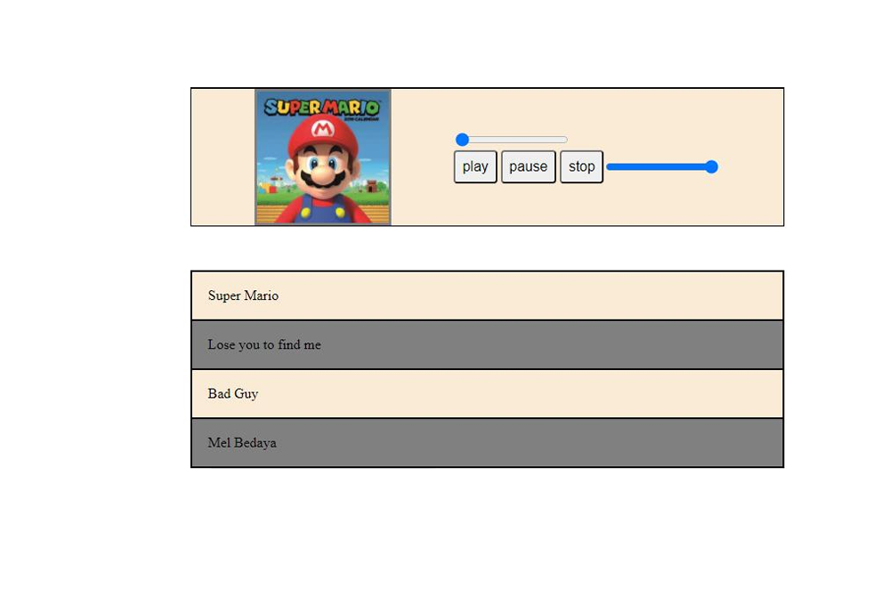
Task 3 : Set and get any value in local storage
Good luck! 🌟

